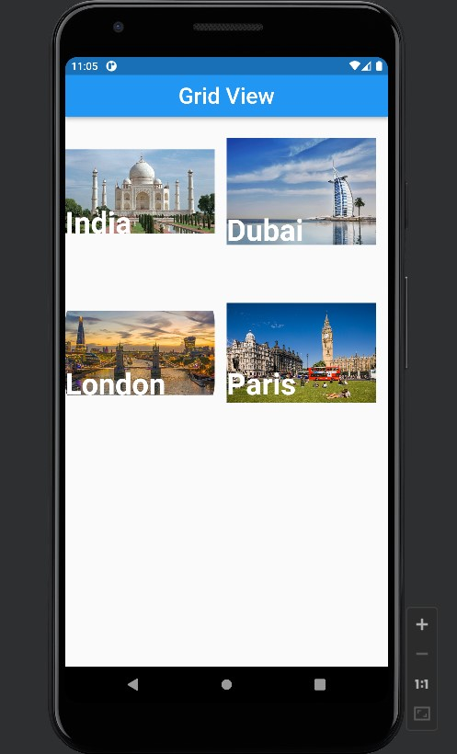

import 'package:flutter/material.dart';  
  
void main(){  
 runApp(MaterialApp(  
 debugShowCheckedModeBanner: false,  
 home: GridV(),  
 ));  
}  
  
class GridV extends StatefulWidget{  
 @override  
 State<StatefulWidget> createState() => _GridVState();  
}  
  
  
class _GridVState extends State<GridV> {  
  
 @override  
 Widget build(BuildContext context) {  
 return Scaffold(  
 appBar: AppBar(  
 title: const Text('Grid View', style: TextStyle(fontSize: 30),  
 ),  
 centerTitle: true,  
 ),  
 body: GridView(  
 gridDelegate: const SliverGridDelegateWithFixedCrossAxisCount(  
 crossAxisCount: 2,  
  
 ),  
 children: [  
 Stack(  
 children: [  
 Image.network(  
 "https://i.natgeofe.com/k/42e832f5-fd48-43ff-b338-091bdf4048ca/india-tajmahal_16x9.jpg?w=1200",  
 height: 200,  
 width: 200,  
 fit: BoxFit.contain,  
 ),  
 const Positioned(  
 bottom: 50,  
 child: Text('India', style: TextStyle(  
 fontSize: 40,fontWeight: FontWeight.*bold*,  
 color: Colors.*white*),),  
 ),  
 ],  
 ),  
 Stack(  
 children: [  
 Image.network(  
 "https://dynamic-media-cdn.tripadvisor.com/media/photo-o/23/6a/ff/2a/caption.jpg?w=700&h=500&s=1&cx=7014&cy=3760&chk=v1_14690e40614ca9b48b73",  
 height: 200,  
 width: 200,  
 fit: BoxFit.contain,  
 ),  
 const Positioned(  
 bottom: 40,  
 child: Text('Dubai', style: TextStyle(  
 fontSize: 40,fontWeight: FontWeight.*bold*,  
 color: Colors.*white*),),  
 ),  
 ],  
 ),  
 Stack(  
 children: [  
 ClipRRect(  
 borderRadius: BorderRadius.circular(60),  
 child: Image.network(  
 "https://cdn.londonandpartners.com/-/media/images/london/visit/campaigns/international-recovery-campaign/lets-do-london-related-international-640.jpeg?mw=640&hash=477E6FF9F31F292EE017E5BA63027C7054EB39A0",  
 height: 200,  
 width: 200,  
 fit: BoxFit.contain,  
 ),),  
 const Positioned(  
 bottom: 50,  
 child: Text('London', style: TextStyle(  
 fontSize: 40,fontWeight: FontWeight.*bold*,  
 color: Colors.*white*),),  
 ),  
 ],  
 ),  
 Stack(  
 children: [  
 Image.network(  
 "https://i.natgeofe.com/n/93231b5d-3b4f-4bd6-bcf4-4172ebda2011/parliment-square-london-england_3x2.jpg",  
 height: 200,  
 width: 200,  
 fit: BoxFit.contain,  
 ),  
 const Positioned(  
 bottom: 50,  
 child: Text('Paris', style: TextStyle(  
 fontSize: 40,fontWeight: FontWeight.*bold*,  
 color: Colors.*white*),),  
 ),  
 ],  
 ),  
  
  
  
  
 ],  
 ),  
 );  
 }  
}